NAME:_______________________________
DATE:________________________________
PERIOD: ______________________________
6TH GRADE COUNTRY RESEARCH PROJECT
For the past few months, we have been traveling around the world learning about the 5 Themes of Geography. As we head to Europe and Asia, we will have the opportunity to apply what we have learned by researching a country of your choice and then share what you have learned with your peers in a “Country Fair.” You will become an expert on your country and present all that you discovered, using a trifold board (please let Mrs. Smith know if you cannot provide your own).
This project will be explained, organized, and worked on in class at the start; however, the majority of the work will be completed at home or during Flex. Students will first gather research materials (books, magazines, websites, etc.) and create a bibliography using www.citationmachine.net . Next, students will read and take notes on the provided organizer. Students will then use this information to write a paragraph for each of the 5 Themes (location, place, region, human-environment interaction, and movement). Students are required to have pictures to support their research.
This is a long-term project and there will be various due dates to complete this project and remain on track. The “Country Fair” will be on:

___________________________________
-------------------------------------------------------------------------------------------------------------
Dear Parents/ Guardians,
Please let me know that you have read this assignment by signing below. Thank you!
_______________________________________________student’s name

_______________________________________________parent signature
TOPICS/ HEADINGS FOR YOUR TRI-FOLD BOARD:
- Location (tells you where it is)
- Absolute location: latitude/ longitude
- Size: total area (in square miles)
- Relative location: nearest oceans and neighboring countries
- Map*

- Place/ Region (what is it like when you get there/ what do locations have in common?)
- Elevation Extremes: highest and lowest points (in feet)
- Physical Features: (mountains, rivers, deserts, lakes, climate, etc.)
- Cultural Features: (population, language(s), religion(s), capital and major cities, buildings, bridges, museums, parks, economy, money, government system, flag etc.)

- Human-Environment Interaction (what do the people do to the environment, what does the environment do for the people?)
- Depend on the land (food? shelter?)
- Adapt to the environment (clothing?)
- Modify/ change the environment (dams, mines, canals, etc.)

- Movement (people <goods> and ideas get around)
- How is this country linked with other countries (physical/ mental)
- Imports/ exports
- Modes of transportation (cars, trains, boats, trams, horses, etc.)

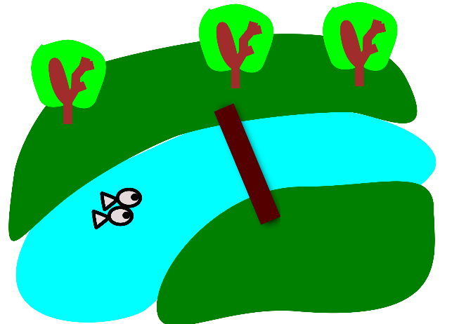
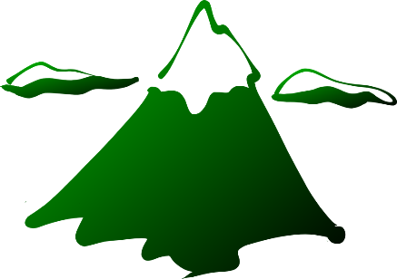

LOCATION:
- Absolute location: ________________________________
- Size (land area in sq. mi) ___________________________
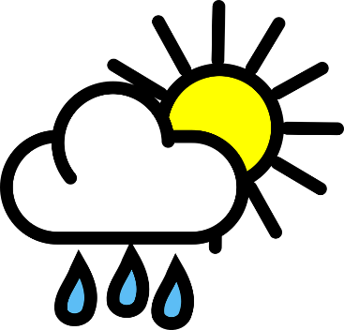
- Relative location: ______________________________________________________________________________________________________________________________________________________________________________________________________________________________________________________________________________

PLACE/REGION:
- Highest point:__________________________________________
- Lowest point: __________________________________________
- Climate: (rainfall, temperature ranges) __________________________________________________________________________________________________________________________________________________________________
- Physical/Natural Features: (mountains, rivers, deserts, lakes, etc. ) ________________________________________________________________________________________________________________________________________________________________________________________________________________________________________________________________________________________________________________________________________________________________________________________________________________________________________________
- Cultural/ Human Features: (population, language(s), religion(s), capital and major cities, buildings, bridges, museums, parks, economy, money, government system, flag (meaning), etc.) __________________________________________________________________________________________________________________________________________________________________________________________________________________________________________________________________________________________________________________________________________________________________________________________________________________________________________________________________________________________________________________________________________________________________________________________________________________
HUMAN-ENVIRONMENT INTERACTION
(depend on, adapt to, or modify/change the environment)
- ____________________________________________________________________________________________________________________________________________________________________________________________________________________________________________________________________________________________________________________________________
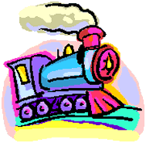
- Clothing: ____________________________________________________________________________________________________________
MOVEMENT (people, goods, and ideas get around)
- Transportation: ____________________________________________________________________________________________________________
- Imports/ exports: __________________________________________________________________________________________________________________________________________________________________
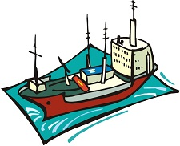
- ______________________________________________________
PICTURES (check when complete)
- At least 2 pictures (including a map) for LOCATION ____
- At least 2 pictures for PLACE/REGION ___
- At least 2 pictures for HUMAN-ENVIRONMENT INTERACTION ___
- At least 2 pictures for MOVEMENT___

BIBLIOGRAPHY
- Go to www.citationmachine.net
- Click on MLA
- Select the type of resource you used
- Fill in the information from your “Sources Page”
- Click submit
- Cut and paste onto a Word document
- Resources should be in alphabetical order by author’s last name

(10 points EXTRA CREDIT—optional!)
- Feel free to bring in a recipe, arts/craft model or replica of something related to your country.
- Some ideas might include: food, beverage, 3-D model of a famous building, statue, artwork, etc.
6th Grade Country Research Project Rubric
- Completed on time | 1 | 2 | 3 | 4
- You expressed location (absolute, relative, and size) | 1 | 2 | 3 | 4
- You expressed place/region (elevation, physical and cultural features) | 1 | 2 | 3 | 4
- You expressed the human-environment interaction of the country | 1 | 2 | 3 | 4
- You expressed movement of the country | 1 | 2 | 3 | 4
- Accurate information | 1 | 2 | 3 | 4
- You completed the notes pages | 1 | 2 | 3 | 4
- You included a Bibliography | 1 | 2 | 3 | 4
- Your board is neat and easy to read (title, subtitles, colored paper, borders, etc.) | 1 | 2 | 3 | 4
- You have at least 8 pictures including a map and a flag | 1 | 2 | 3 | 4
- Accurate spelling, punctuation, and capitalization | 1 | 2 | 3 | 4
- EXTRA CREDIT (1-10 POINTS)

POINTS EARNED: ______/44
EXTRA CREDIT +__________
TOTAL POINTS =___________

